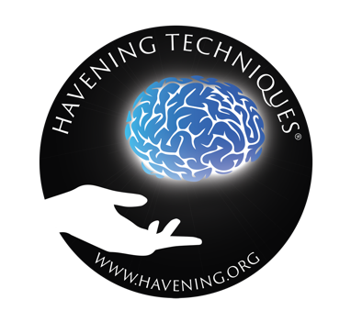
A modern approach to the challenges of today.

The Healing Power of Touch:
How modern neuroscience can help you live a better life!

... what is Havening?

We find ourselves in an increasingly fast-paced age. The world is growing together more and more globally, and at the same time, information is available almost immediately at the push of a button via the Internet and social media. We’re becoming more and more independent of physical boundaries and time factors – information overload, anywhere, anytime.
For all the advantages these changes bring about, the speed at which they are happening also bring problems: many people find it increasingly difficult to focus on themselves and thus on their own personal strengths and qualities.
Another fact to consider: The demands on therapy, coaching and change-work have grown immensely. No one wants to spend many years in therapeutic processes anymore just to find out where one's problems come from - but without having found any answers on how they can be solved. Results of psychotherapy and coaching need to be rapid and sustainable at best.
This is where Havening comes in: a revolutionary new technique developed in New York (USA) over the last twenty years and now used by hundreds of coaches, therapists and counselors all around the world. With remarkable results: Not only does Havening yield impressive results in trauma therapy, it is also widely used in many other areas of therapy and coaching – ranging from mental sports coaching over pain therapy to deep healing and unleashing of inner resources.
Some Practitioners of the technique call Havening a true game changer, bringing a breath of fresh air to personal development techniques. Others see it as a disruptive technique that turns the world of traditional therapies on its head through its sound neuroscientific approach combined with the completely natural healing power of touch.
Clients who have experienced the power of Havening often call this technique a "true gift": the feedback received by Practitioners shows time and again how useful and helpful Havening can be.

Heart and head, hand in hand: the best mix of both worlds.
Our scientific curiosity, our minds and brains will be pleased that Havening was formulated on the sound basis of neuroscientific knowledge and research: Thus, clients experience treatment by means of a reliable, comprehensible program. The way change happens - it becomes explainable.
Yet Havening is anything but dry and boring, nor does it get stuck in the cognitive realm: the therapeutically applied, physical touch (the Havening Touch - heart of the technique) makes the subjective experience of receiving Havening feel cathartic, liberating and soothing! Heart and soul feel refreshed, no matter what purpose you use Havening for.
In this document, you will find some essential information about the Havening Techniques®. If you have any further questions - or would like to experience the power of Havening for yourself: Numerous qualified and certified users all over the world are looking forward to introducing you to this fascinating technique!

Havening in a Nutshell
Havening uses Touch in order to change neurobiology
Havening means "to bring into safe harbor / haven"
Activation of Delta Waves, release of Oxytocin, GABA and Serotonine: Perfect enviroment for neuronal change processes.
Scientific foundation: neurobiology and neuroplasticity
over 20 years development time, experience with 10.000s of clients
Developed in the USA by physicians / neuroscientists Dr. Ronald M. Ruden and Dr. Steven J. Ruden
Universal Applications: Resolution of trauma as well as strengthening of resources
Can be elegantly combined with other techniques, such as conversational psychotherapy, hypnotherapy or trauma therapy
International standards ensure the same high quality no matter where you experience Havening: Worldwide protected & standardized procedure.
Strengthens resilience, the psychological immune system

Havening – a brief explanation
Havening Techniques use our inherent biological/neurological system to supply relief, symptom alleviation or healing on both a physical and mental/spiritual level.
Through therapeutically applied physical touch (gentle stroking movements) in the area of the arms, hands and face, the dominant brain frequencies are changed, while at the same time a release of helpful hormones takes place (serotonin, oxytocin, dopamine and GABA).
The Practitioners of Havening have a wide range of so-called process interventions at their disposal, from which they can choose - depending on the clients’ individual objectives and exact need for change - and which can be skillfully combined with each other.
Havening Touch can either be applied by the Practitioner, or he/she will guide you to perform the Havening Touch on yourself. Thanks to a sound and standardized training, officially certified Practitioners are so experienced that they know exactly what speed and what pressure is most useful in the process .

How did Havening come into being?
The key moment for the emergence of the Havening Techniques lies in 2001, when physician and neuroscientist Dr. Ronald M. Ruden had a professional discussion on the issue of trauma with a colleague and both were astonished to discover that there are quite a few methodologies in trauma therapy, some of which have dramatically different approaches - and yet again show great similarity in the critical time phase at the end of therapy, when the trauma is released and the clients can free themselves from the negative effects of traumatization.
Many roads lead to Rome, and it’s great for clients to have a variety of different treatment modalities to choose from. But then again: Why not come up with a road map that shows the exact pathways to Rome? Or, neurologically speaking: Even with different treatment modalities around, the neurological change processes taking place in the brain seem to be similar (if not the same) when trauma is released – so why not gather this knowledge and pinpoint the neurological pathways affected by trauma and show what happens with them when trauma is released?
Inspired by this conversation, Dr. Ruden tapped into his inner Sherlock Holmes and has spent many years on research, development and observation, bringing together practical trauma therapy and theoretical neurological knowledge. Which approaches have proven particularly successful in trauma therapy? Which interventions and techniques work better than average - and which work less well? Which studies prove to be particularly meaningful? And: How can the development of trauma be explained in the context of neuroscience?
The results of his research led to a book on trauma "When the Past is Always Present" and a little later to a collection of therapeutic techniques that use the natural healing power of touch on the basis of a neuroscientific explanatory model: The Havening Techniques.
After thousands of clients had experienced the effects of Havening in Dr. Ruden's New York practice, it was time to introduce other therapists and coaches to the technique. Thus, the first training to become a certified Havening Techniques Practitioner took place in London in May 2013. Further trainings followed, and since 2015, particularly qualified practitioners can also become trainers in this technique themselves after an extensive special training. The Havening community is now growing more and more every year, so that you can find hundreds of qualified practitioners all over the world - from Alaska to Zimbabwe, and everywhere in between.

How Havening Works
Behind you lies a long voyage at sea: You have skillfully navigated your ship through the raging waves. You have successfully braved the storms and the tempest. But:
Not only are your ships supplies slowly coming to an end, but so is your own strength. You have given everything and completely exhausted yourself. Now you can hardly wait to finally get solid ground under your feet again ...

Finally! You see the lighthouse in the distance, and how its light signal promises your imminent arrival! Anticipation sets in: finally you can let go of the ships steering wheel, refuel your supplies – and come to a much needed rest. You leave the uncertainties and difficulties of the rough seas behind you. Soon you will enter the harbor that gives you safety and security ... your much needed Haven.

The term HAVENING is derived from the noun Haven, and represents symbolically the mental entry into a safe harbor. This is one of the critical conditions needed in therapy in order to unburden oneself of the lingering ill aftereffects of past trauma (and is well-explained in Havening with the “EMLI”-model).
The safe haven can be provided by Havening Touch and the respective process interventions - and this would also clarify how Havening got its name (which, by the way, has nothing to do with "Heaven" - although according to our clientsm a Havening session often feels quite heavenly ...).
HAVENING is
a safe haven for your soul
Havening always takes place in conjunction with a therapeutic conversation (or coaching dialogue). Depending on the practitioner's general specialization, Havening can of course also be used in synergetic combination with another therapeutic modality, such as cognitive behavioral therapy, goal coaching or hypnotherapy.
Within the Havening Techniques, various process interventions are available for Practitioners (and their clients) to choose from. The whole is greater than the sum of its parts: During their training and certification process, Practitioners will develop the ability to skillfully combine, pattern and structure the individual interventions into a wholesome coaching or therapy.
A selection of possible process interventions:
E
vent-Havening
Is usually used in cases of classic trauma, such as post-traumatic stress disorder or even complex trauma. However, it can also be excellently used to resolve intrapsychic blockages or psychogenic pain.
T
ranspirational-Havening
Here, a process of inner association is set in motion; in this way, work topics can be better delimited and it is much easier to solve the problem at its root in a causally oriented manner; in addition, stuck, pent-up emotions can be released and set free.
A
ssociation-Havening
Affirmations which are directed at the unconscious structures of the human being (instead of at the cognition), are anchored particularly powerfully and lastingly by means of Havening Touch.
R
ole-Havening
The perfect combination of systemic therapy and Havening: imagined encounters and interactions are accompanied by the Havening Touch; excellently suited for clients who did not receive sufficient resources in childhood - and thus, of course, as an intervention also predestined for childhood traumas.
M
irror-Havening
A mixture of Havening Touch and imaginative work, intensively activating the inner wealth of resources
I
ffirmation-Havening
A model co-developed by the British therapist Tony Burgess, which pursues the approach of breaking through inner inhibitions and blockages with the help of precisely formulated language; is preferably used in coaching as well as in sports mental training.
For a successful application of the Havening Techniques the right choice and combination of the respective process interventions is crucial. Both goal setting and the individual taste of the client play a role. Here you can trust the experience of your practitioner to put together a skillful mixture of the respective procedures - or to work with only one single process intervention if this should be most suitable for your concern.

The core of the technique is the Havening Touch: Therapeutically applied, gently stroking movements on the arms, on the palms and in the facial area. This touch can be applied either by the counselor / therapist, or by the clients themselves. The areas of touch are precisely agreed upon beforehand and Havening Touch leads to a release of the following hormones through its application:

Serotonin
5-hydroxytryptamine (5-HT)

provides serenity, inner peace, gives a feeling of satisfaction
Oxytocin
is popularly known as the "cuddle hormone"; oxytocin not only creates a familiar feeling, but also activates the internal reward system and also inhibits the release of cortisol
Dopamine
is also known as the happiness or anticipation hormone, and plays a role in both the development and resolution of trauma
GABA
γ-Aminobutyric acid
GABA not only has a relaxing effect, but also inhibits external stimuli and at the same time increases the internal associative capacity

Change of neuronal milieu / environment
Havening can be used two-ways:
- During the therapeutic treatment of trauma, the synaptically stored link between the traumatic experience and the feeling perceived as unpleasant in the amygdala is dissolved through hormonal regulation and the change in the dominant brain frequencies.
- when strengthening inner resources, neuroplasticity is increased - this is the ability of the human brain to make new (desirable) connections and dissolve old (obstructive) neural pathways
When trauma occurs, the amount of very high frequency brain frequencies (gamma range) increases dramatically. In the resolution of traumatic experiences, on the other hand, the amount of low-frequency brain frequencies is increased by the Havening Touch: These are the delta waves.
For this reason, Havening is also often nicknamed Amygdala Depotentiation Technique ADT or Delta Wave Technique. Havening belongs to the discipline of psychosensory therapies because of the component of therapeutic touch.

Coaching or therapy? Havening as a multi-talent in both disciplines.
Havening was formulated on the basis of neuroscientific findings and is often used in psychotherapeutic or even medical contexts - for example, when trauma is to be processed.
Nevertheless, Havening all by itself is not a therapy – but it does become one when the corresponding Havening interventions are used in a suitable setting and in connection with other therapeutic processes.
The core of Havening - the Havening Touch - as a pure technique can therefore be used just as well in the areas of coaching and counseling. And also in group settings the Havening Techniques can be worked with wonderfully, for example with a group of pupils / students as preparation for an exam or to lay the foundation for a particularly efficient learning experience.
Havening Techniques Practitioners all have their different specializations, core competencies and also contexts of application. Not every practitioner will work on every concern / change request, but will focus exclusively on the topics for which she / he is also best qualified. If your concern does not fall within a practitioner's core competency area, you can be confident that you will be referred to a practitioner who has the appropriate expertise in the concern relevant to you.
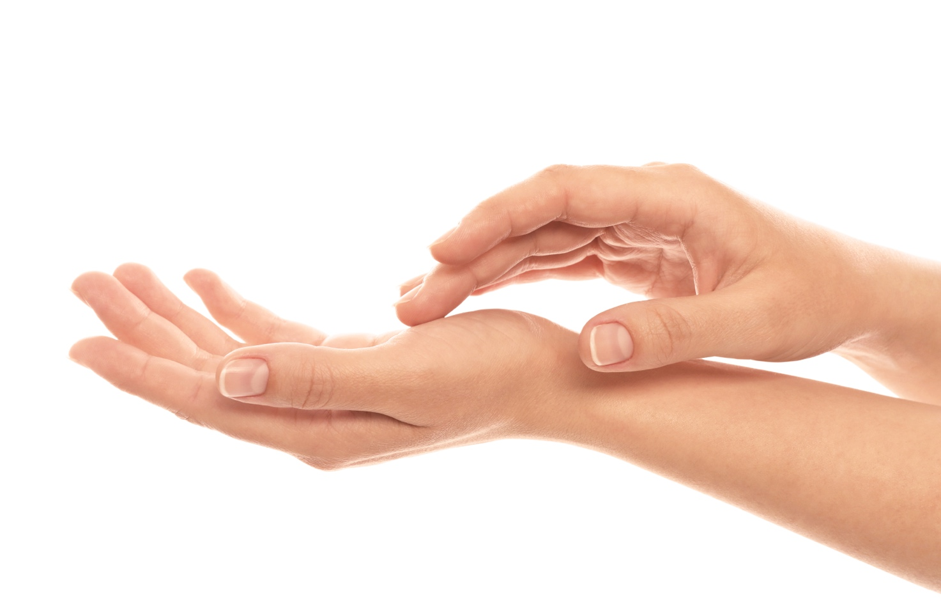

What can Havening be used for?
As a rule, Havening can be used everywhere where conventional psychotherapies and coachings are used. The spectrum of application can be divided into reduction of undesirable and strengthening of resources.

Reduction of undesirable
- Phobias
- psychogenic / chronic pain
- Separation, loss and mourning
- persistent grief
- depression
- Reduction / resolution of stressful emotions
- Trauma
- Multiple or complex trauma
- PTSD / cPTSD
- Rage issues
- Fear of loss
- Chronic stress
- lack of self-esteem
- Addictive disorders
- Panic disorder / generalized anxiety disorder
- common fears
- Presentation, speech and social anxiety
- emotional, physical and / or sexual abuse
- Eating disorders
- Constraints

In trauma work, Havening is often used after serious experiences, such as assaults, attacks with physical or sexual violence, natural disasters, war, accidents, fire / fires and burglaries. However, a great strength also lies in the therapeutic processing of the often little visible traumatization caused by emotional abuse / emotional violence, e.g. caused by a difficult childhood or even after a toxic relationship.

Strengthening resources
Although Havening was a classic trauma therapy at the beginning of its development, the area of resource strengthening was quickly added due to the growth of process interventions, so that Havening is now also used for:
- Coaching (business, life and personal)
- Reconciliation with the inner child
- Courage strengthening
- Increase self-confidence
- Increase confidence and optimism
- Improvement of self-discipline
- Sports Mental Training
- Optimization of own flexibility
- Creativity enhancement
- Promotion of learning, memory and recall skills
- Memory and concentration training

Given the wide range of different applications, it is no wonder that many leading business personalities and celebrities from media, sports and the arts are now die-hard fans of the Havening Techniques and enjoy professional coaching or therapy by certified practitioners. But - due to the low-threshold availability and the fast as well as sustainable effect, Havening is especially popular with all the "regular folks with regular problems" and is frequently and gladly used for coaching as well as for therapeutic purposes.

Are the results achieved by Havening permanent?
In classical trauma therapy, therapists and clients alike will want to achieve a truly lasting result. Due to the unique neuroscientific structure of the Havening Techniques, this can be guaranteed in a lot of cases by neurologically delinking the traumatic memory from the accompanying emotion. This happens in the amygdala – the emotion / fear part of the brain.
Every person is different, every case is different - and of course a serious therapeutic intervention cannot and does not want to make any promises of healing. It is also not possible to state an exact number of sessions in advance - some results are achieved in only one session, and sometimes client and therapist have to find a good therapeutic access vector together which can take some time.
Clients often describe having found the Havening Techniques as a godsend after a long struggle and many unsuccessful therapies before. Practitioners are trained to carefully devise an individual coaching / therapy for each client with the goal to achieve change that not only happens quickly, but also permanently.

The Havening Organization - international quality according to reliable standards
Havening's headquarters are located in New York City, USA. Not only do the main creators of the Techniques live here, but a lot of training courses are also held here.
Havening's homepage can be found at: https://www.havening.org
In the expert search there you have the possibility to look for qualified Practitioners in your area, or to find a training institute, if you are a coach / therapist yourself and want to further educate yourself in this technique.
All experts listed on the website have:
- underwent a certified training according to international standards
- demonstrated their competence in the practical application of Havening within the framework of case descriptions documented in writing and on video
- documented their theoretical understanding of the Havening Techniques by means of a written examination
Experts registered there have the opportunity to continuously educate themselves in an extensive, internal audio, video and text library, so you can be sure to always receive Havening treatment according to the latest standards.
Therefore, please make sure to use Havening only with officially recognized (and listed on the website) Practitioners!

Further information
A lot of additional information can be found on the official Havening website:
https://www.havening.org
Studies, white papers, and other English-language explanations:
- White papers can be accessed at:
https://havening.org/about-havening/articles
- Doug O'Brien - Brief Introduction (a brief introduction to Havening):
https://www.youtube.com/watch?v=T0kf-92YmuE
- Tam Johnston - How does Havening Work:
https://www.youtube.com/watch?v=VD6PcEWDJbo
- Estelle Read Easy Self Havening:
https://www.youtube.com/watch?v=Mr8TkgIUxYI
- Dr. Ron Ruden published in Science Direct Harnessing Electroceuticals to Treat Disorders Arising From Traumatic Stress: Theoretical Considerations Using A Psychosensory Model:
https://www.sciencedirect.com/science/article/pii/S1550830718301848
- Havening Research Paper:
https://www.hsj.gr/medicine/impact-of-a-singlesession-of-havening.php?aid=7273
- Published Research 2020 - A Psychophysiological Examination of the Mutability of Type D Personality in a Therapeutic Trial:
https://econtent.hogrefe.com/doi/pdf/10.1027/0269-8803/a000266?ct=t%28EMAIL_CAMPAIGN_8_19_General_COPY_02%29&mc_cid=9ff34e9b78&mc_eid=6a65923537&

Contact
You have further questions about Havening? Would you like more information, would you like to become a client - or would you like to train yourself in this fascinating technique? Feel free to contact us at any time - we look forward to hearing from you!
You can reach Havening headquarters by email at info@havening.org.
On our website you will also find an expert search function that will help you find qualified experts in your area.

